RISING SUN JUDO CLUB

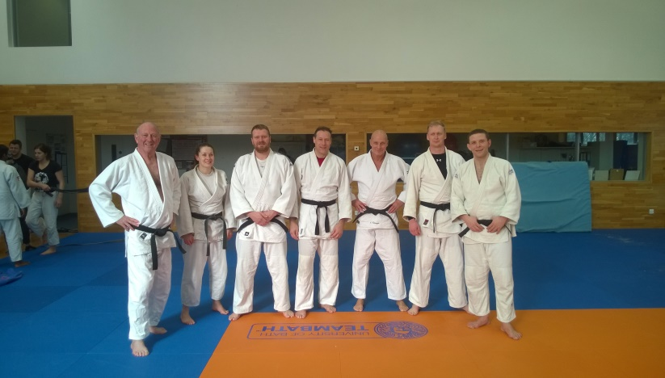

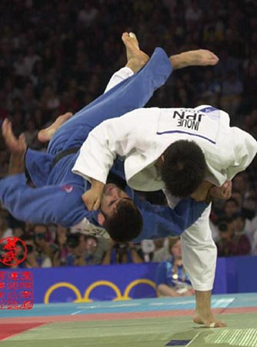
Judo – still the best all round defence system. Ju - “gentle” Do “ way”

JUDO
Judo was refined from jujitsu, a comprehensive system of armed and unarmed combat which was developed for over 300 years in Japan.
It is also a philosophy for life, in that it requires the cooperation of and assistance of another person to learn and practise with, so players must work together. Jigoro Kano recognised this and in 1881 developed judo as a sport and also a means of personal development. He eliminated the techniques that were too dangerous and damaging to widely practise hard without an increased risk to the person. However, many original techniques do remain in judo in a more controlled form. Judo is widely translated as Ju = gentle and do = way (of life), although it is never gentle, and Ju is better translated as supple, flexible or yielding. Judo can be practised by people of all ages, although our minimum age for children is generally 8.

Although personal safety is always the first concern, parents must note that their child may get hurt during the activity however much care is taken, as of course is the case with football and many other sports. They must also note that judo is a hands-on full contact martial art which involves child to child and adult to child contact.

THE CLUB
The Club is a registered member of the British Judo Association (BJA), and is run under BJA rules. The BJA is the official national governing body for judo in the United Kingdom. The BJA is affiliated to the Sports Council, the British Olympic Association, the European Judo Union, and the International Judo Federation. The British Judo Council (BJC) and the Amateur Judo Association (AJA) are affiliated to the British Judo Association, and are the only other recognised judo organisations in the UK.

The Club started in 1990 and we believe in leading from the front and show both technical and competitive judo.

INSTRUCTORS
All instructors are national governing body qualified and authorised. This provides liability insurance, DBS checking, First Aid qualification, and Child Protection qualification. In addition, each instructor must attend regular judo educational courses.

The club is owned and run by:

Erin Southam BA (Hons) 1st Dan. Erin has been practising judo for over 25 years, and has won Sussex County Open Championships many times at both junior and senior level. She is also a former Southern Area gold medallist. With her degree in PE & Sports, she is also a qualified coach in other sports.

Pawel Wojtas 1st Dan. Pawel has been practising judo for over 25 years, and is a former Polish National Junior bronze medallist. He has also won many regional competitions including a 5th place at the Polish University Championships, as well as competing in France and Germany. He is also a former Sussex County and Southern Area medallist.

Dave Wright 3rd Dan. Dave is both a former Sussex County champion and medallist and a National Masters gold and silver medallist, and has over 35 years’ experience of judo. He was also a Sussex County Squad Instructor for 12 years.
Our Assistant Club Instructor is Joel Hammond 1st Kyu, a former Sussex County medallist. Our Club Welfare Officer is Erin Southam.

JUDO FOR EVERYONE
Some players enjoy judo simply as a recreation, some like to enter competitions. Although we may invite people to enter competitions, they are never coerced. Equally, those that want to compete will only be entered for events that are right for them at their particular stage of judo. We encourage everyone to enjoy their judo at whatever level they want.

CLUB CENTRES

SUNDAYS: The Studio, Worthing Leisure Centre, Shaftesbury Avenue, Worthing BN12 4ET
WEDNESDAYS: Ashington Community Centre, Foster Lane, Ashington RH20 3PG

CLUB TIMES

Beginners session on Sundays only 4.30 - 5.30pm
Juniors on Sundays yellow belt and above 4.30 – 6.00pm
Seniors on Sundays 4.30 – 6.00pm
Graded players only Wednesdays (additional session only) 7.45 – 8.45pm

TRAINING FEES 2019
SENIOR CLUB MEMBERS
Sundays only: £30pm standing order
Sundays & Wednesdays: £50pm standing order
Wednesdays only: not available
JUNIOR CLUB MEMBERS
Sundays only: £25pm for white and red belts
£30pm for yellow belt & above

We will only accept fees paid by standing order, and these will be paid in advance and in full before your next month’s training. We have to allow cash payments for some seniors who either have shift work or are “on call” because of their work and cannot control their attendance. The fees are averaged over a year and allow for holidays and the times we are shut, i.e. Christmas. We will also deal individually with players who are signed off for periods in excess of 2 months due to injury.

NEW MEMBERS – WHAT HAPPENS AND HOW WOULD I JOIN?

JUNIOR BEGINNERS
Your first taster session from 4.30-5.30 is free. After that, your sessions will continue from 4.30 – 5.30 at £6.00 per session.

By the end of the first month, most people have decided whether they wish to continue judo, and if so, you will join us as a club member. You will then set up a Standing Order from the beginning of the next month.

During your second month you will need to obtain a licence from the BJA which provides insurance cover.
A licence is currently £27 for a junior and £38 for a senior.
By the end of the second month, most people are quite able to take their first grading. We cannot grade anyone nor can you enter any event without a current licence. The grading fee in 2019 is £12.
You will need to buy your own judo suit, and we have a stock of these and can advise you on sizes and shrinkage, and a training grade quality judo suit is around £20.

SENIOR BEGINNERS
We deal with seniors individually, especially those with previous martial arts experience.

HOW TO JOIN
We hope you or your child will want to join us. We need you to fill in a membership form, as we must have some personal details as good practice. If you have any questions now or in the future please talk to any of the instructors. We run the club for our members’ benefit.

HEALTH
For your own safety you must tell us about any medical condition that we should know about, and any medicines which you are taking or which you cannot take. We must have an emergency contact telephone number for you.

BEHAVIOUR
Unruly behaviour is a problem in any class, but in judo, safety is an extra factor. In a sport where people are being thrown, it is essential to keep self control and self discipline. If you try to throw someone without sufficient control, you are just as likely to hurt yourself instead of the person you throw. We will remove any child from the mat if we feel there is a risk to themselves or others due to inappropriate behaviour.

CLUB RULES – please remember and obey them
Your judo suit, and your hands and feet must be clean, and finger and toe nails kept short to avoid cuts to yourself or others.

You must bow when entering or leaving the hall, and when stepping on and off the mat. This is basic judo etiquette – good manners.

You must bow to your partner/opponent before a practice and after a practice. This is basic etiquette – good manners.

YOU MUST PUT YOUR SHOES ON WHEN YOU LEAVE THE MAT – no one wants the dirt from your feet on them.

RISING SUN JUDO CLUB MEMBERSHIP FORM

PLAYER’S NAME……………………………………………………………………………………………………………..

PARENT/GUARDIAN/CARER NAME (if under 18)……………..……………..………………………..……………….

PARTNER/HUSBAND/WIFE NAME (if over 18).……………………………..……………………….………………….

YOUR ADDRESS……………..………………………………………………………………………………………………

…………………...............................................................................................................................................

POSTCODE....................................................................................................................................................

LANDLINE (optional)...............……………..……………………………………………………………………………….

OWN MOBILE ….………………………………………………………………………………………………………………

EMERGENCY CONTACT MOBILE …………………………………………………………………………………………

EMAIL ADDRESSES…………………………..……..……………………………………………………………………….

….......………………………………………………………..………………………………………….

DATE OF BIRTH.........../…......./…….......

Sporting information
Have you played judo before, if so where?

If yes, do you have a current BJA or BJC or AJA licence

Have you done other martial arts?

Do you play other sports?

Disability
The Disability Discrimination Act 1995 defines a disabled person as anyone with ‘a physical or mental impairment, which has a substantial and long-term adverse effect on his or her ability to carry out normal day-to-day activities’.
Do you consider yourself to have a disability? Yes No
If yes, what is the nature of your disability?
Visual impairment
Hearing impairment
Physical disability
Learning disability
Multiple disability
Other(please specify):

Medical information
Please detail below any important medical information that our coaches should be aware of (e.g. epilepsy, asthma, diabetes, etc.)
Are there any medicines that you take currently? Are there any medicines you are allergic to and cannot take? We would need to know this in the event of an emergency.

General Consent
By returning this completed form, I agree to me/my son/daughter/child in my care taking part in the activities of the club. I understand that I will be kept informed of these activities – for example timing of lessons, competitions etc. We never email juniors under 16 directly but use parent or guardian email addresses, and the same process is used for mobile numbers.

Injury Consent
I understand that in the event of any injury or illness all reasonable steps will be taken to contact the appropriate person, and that any of the instructors can act In Loco Parentis if necessary to deal with that injury/illness appropriately to provide the best outcome.

Photography Consent
We may take either individual or group photos from time to time. These may be posted either to our website (www.rsjc.co.uk) or to our Facebook page (www.facebook.com/rsjcworthing). Photographs are not the property of the club, nor does the club hold any responsibility for their future use. I agree to allow photographs to be taken and posted to the above sites.

Data Protection Consent
We hold the information you have given us on the form above. Details are stored on a password protected internet database. Only the owners of the club as listed above hold the passwords. The system is updated where necessary with any changes, and attendances are logged after each session. The paper copy is shredded once the data is logged.
You may ask us to see what data we hold about you. We do not share this data with anyone else nor sell it to a third party. You have the right to withdraw your consent for us to hold this data, and the right to ask us to delete all data. In that case we will no longer contact you with club information, although we will continue to hold an emergency phone number for safety reasons for as long as you attend the club.
If you do not attend for 3 months, you will be deemed to have left the club and we will delete any remaining data.

Signature of parent/guardian/carer if applicant is aged under 18 accepting the 4 consents above

Signature of applicant if aged 18 or over accepting the 4 consents above

Date……………………………………………

